I have found a potential issue in the RDFS file on the EQ profile. The question is, whom should we report such issues?

The [LTDS Grid Modelling Annex 2 - Data Exchange Specifications](https://www.ofgem.gov.uk/sites/default/files/2024-04/LTDS%20Grid%20Modelling%20Annex%202%20-%20Data%20Exchange%20Specifications.pdf), page 32, states that the BoundaryPoint class does not support the parameters from the European package (fromEndIsoCode, fromEndName, etc.)

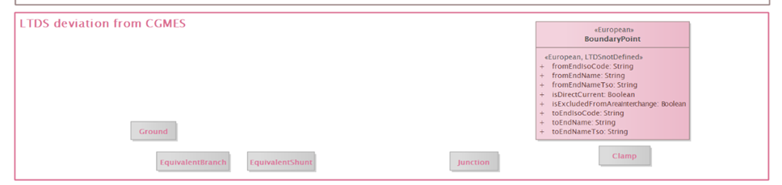

However, these parameters can still be found in the RDFS-Merged file for the EQ profile, and are defined as “required” ([Grid Modelling Appendix 3 - LTDS Profiles in RDFS (zip)](https://www.ofgem.gov.uk/sites/default/files/2024-04/Grid_Modelling_Appendix_3_LTDS_Profiles_in_RDFS.zip)).

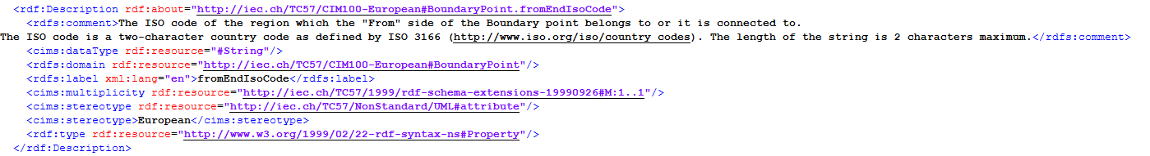

This is causing problems in CIM validation of LTDS data.

Best regards,

Emil